Greater Manchester Social Care Commission report

Final Report – March 2026

This report is written in Easy Read format.
This format reflects our commitment to making inclusive communication the norm across Greater Manchester.
There is also a British Sign Language (BSL) version of this report.
A text-only version is also available.

Our Recommendations for Change
The Greater Manchester Social Care Commission was created so that people with lived experience could lead conversations about adult social care reform.
We focused on the issues that affect people’s daily lives:

Social Care Charging
Accessible information and Communication
Advocacy.

We worked together to turn real experiences into practical recommendations for change.
The recommendations are presented first. The following sections explain how we reached them and who contributed to this work.

Our Recommendations for Change

Accessible Information and Communication
We recommend that:
- Named Social Worker model
People who access adult social care should have a named contact they can approach when they need support, rather than having to go through the front door each time they need to speak to someone.

- Accessible documents by default
Documents explaining the key social care processes
should be available in accessible formats without people having to ask for them. These documents should be stored in a central hub so they can be easily found and used by both staff and people accessing support.

- Reasonable adjustment flags
Services need to have a system to ensure that people’s reasonable adjustment requirements are not simply recorded but are consistently met.

Social Care Charging
Our long-term ambition:
Our ambition for the future is that social care charging is removed altogether.
The things we will work on to make things better now:
- Reduce charges and prevent debt
Develop a fair model for social care charging, which prevents people falling into debt
- Clear and understandable charging information
Information about social care charging should be clear and easy to understand, including how much someone has to pay and how the charge has been worked out.
- Help to navigate the charging system
People have access to independent advice and support, helping them to navigate the social care charging system.

Advocacy

Statutory advocacy should be properly resourced to ensure that everyone who is entitled to and wants an Advocate gets one.
Lots of people need help to access social care because it is so complicated but they are not eligible for an Advocate under Care Act.
There should be properly resourced independent general advocacy available to anyone that needs it so they can access and navigate the social care system.

Background and Purpose of the Commission
The Greater Manchester Social Care Commission was commissioned by the Mayor of Greater Manchester to take a fresh and honest look at adult social care in Greater Manchester. The Greater Manchester Disabled People’s Panel then did some work to develop ideas for how the Commission could work.
In the summer of 2025 NHS Greater Manchester and the Greater Manchester Combined Authority were able to provide funding to get the Commission started.
The Commission Team was made up people with lived experience, people representing equality groups and was facilitated by Embrace Wigan & Leigh and Disability Stockport.
From the outset, members were clear that this would not be “just a listening exercise.” The purpose was to:
- Put lived experience at the centre of reform.
- Identify where people are experiencing barriers or difficulties.
- Provide a safe space where we could have proper discussions
- Develop practical and realistic solutions.
- Influence system changes across Greater Manchester.
As discussed during early meetings, we agreed that we must start with people’s lives, not the cost — “Person First.”
The Commission was not created to duplicate existing structures. It was created to bring lived experience, representative voices and system leaders together in one place to focus on action. It created a forum where people could speak openly, listen to one another, and work collectively towards strengthening adult social care across Greater Manchester.

Our Shared Long-Term Ambition – what success looks like
We all agreed that our ideal would be a social care system where:
- Care and support are free for everyone who needs it
- Accessible information is provided automatically
- Advocacy is available whenever it is needed
- People have real choice and control over their lives
- Lived experience remains embedded in decision-making.
This reflects our shared belief that social care should support independence, dignity and equality.
As agreed in our first meeting:
“We will see tangible outcomes and change will have happened. Those with lived experience will experience positive change.”

What voices do we have on the Commission
The Commission brought together a broad and balanced membership, including:
- People who use Social Care
- Deaf and hearing impaired people
- Learning disabled self-advocates
- Older people
- Women and Girls
- Global Majority communities
- Family carers
- Independent adult social care providers
- Greater Manchester Combined Authority
- Directors of Adult Social Care (ADASS)
- NHS Greater Manchester
- Voluntary, Community and Social Enterprise organisations
This ensured that lived experience was central while maintaining constructive relationships with system leaders.
Laurel Issen, Salford Disability Forum volunteer, reflected:
“Being involved with the Commission as an expert by lived experience felt like such an empowering example of co-production… it didn’t feel like us-vs-them at all, it felt like teamwork where all of our unique perspectives were valued in coming up with solutions.”

How We Worked
The Commission met monthly from October 2025 to March 2026.
Members agreed inclusive ground rules:
- No jargon.
- Speak clearly.
- Respect access needs.
- Co-produce as equals.
A Code of Conduct, produced in Easy Read, was adopted to ensure the project remained safe, inclusive and constructive.
Members agreed to use a solution-focused approach. This meant we did not only describe problems — we worked together to develop achievable improvements.
We:
- co-produced all of our Commission meetings.
- Established two focused sub-groups (Social Care Charging and Accessible Information & Communication).
- Held a discussion session with Deaf participants.
- Held a discussion session with learning disabled self-advocates.
- Engaged older people’s networks.
- Met with senior system leaders responsible for priority topics.
- Met with Salford’s Fairer Charging and Welfare Rights team.
- Contributed to national reform discussions, including Local Government Association consultation processes.
An Oversight Group was established to support governance and connect the Commission to decision-making routes across Greater Manchester.
Co-production was not just something we talked about — it shaped the whole process.
- Members voted on how we would work together
- Members voted on the priority themes.
- Members agreed what they thought the main issues were
- Members came up with ideas for solutions and discussed them with system colleagues
- Members agreed the recommendations
We made deliberate choices to:
- Work through the process together as a shared journey
- Create space for questioning
- Understand each other’s roles and constraints
- Agree solutions that could work in practice
This was not about presenting a list of demands.
It was about developing ideas that made sense both for people who use social care and for those responsible for delivering it.
As one member reflected:
“For many of us, this was the first time people with lived experience and system leaders had been able to sit together openly and work through issues side by side.”

What We Heard
People brought many different experiences into the room, reflecting how broad and complex adult social care is. We recognised from the outset that we could not cover everything.
Through open discussion and co-production with social care colleagues, we agreed to focus on three areas where shared experiences showed there was value in working together to strengthen practice and build on what is already happening. These were:
Accessible Information and Communication,
Social Care Charging, and
Advocacy.
The following sections set out what we heard in relation to each area.

Accessible Information and Communication

These pictures are of our workshop with Learning Disabled Self-Advocates from Manchester People First

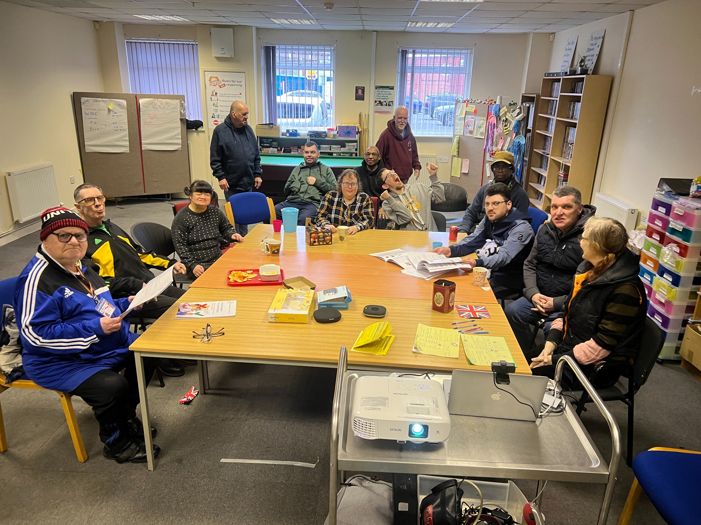

These pictures are of our workshop with Deaf people from all over Greeter Manchester

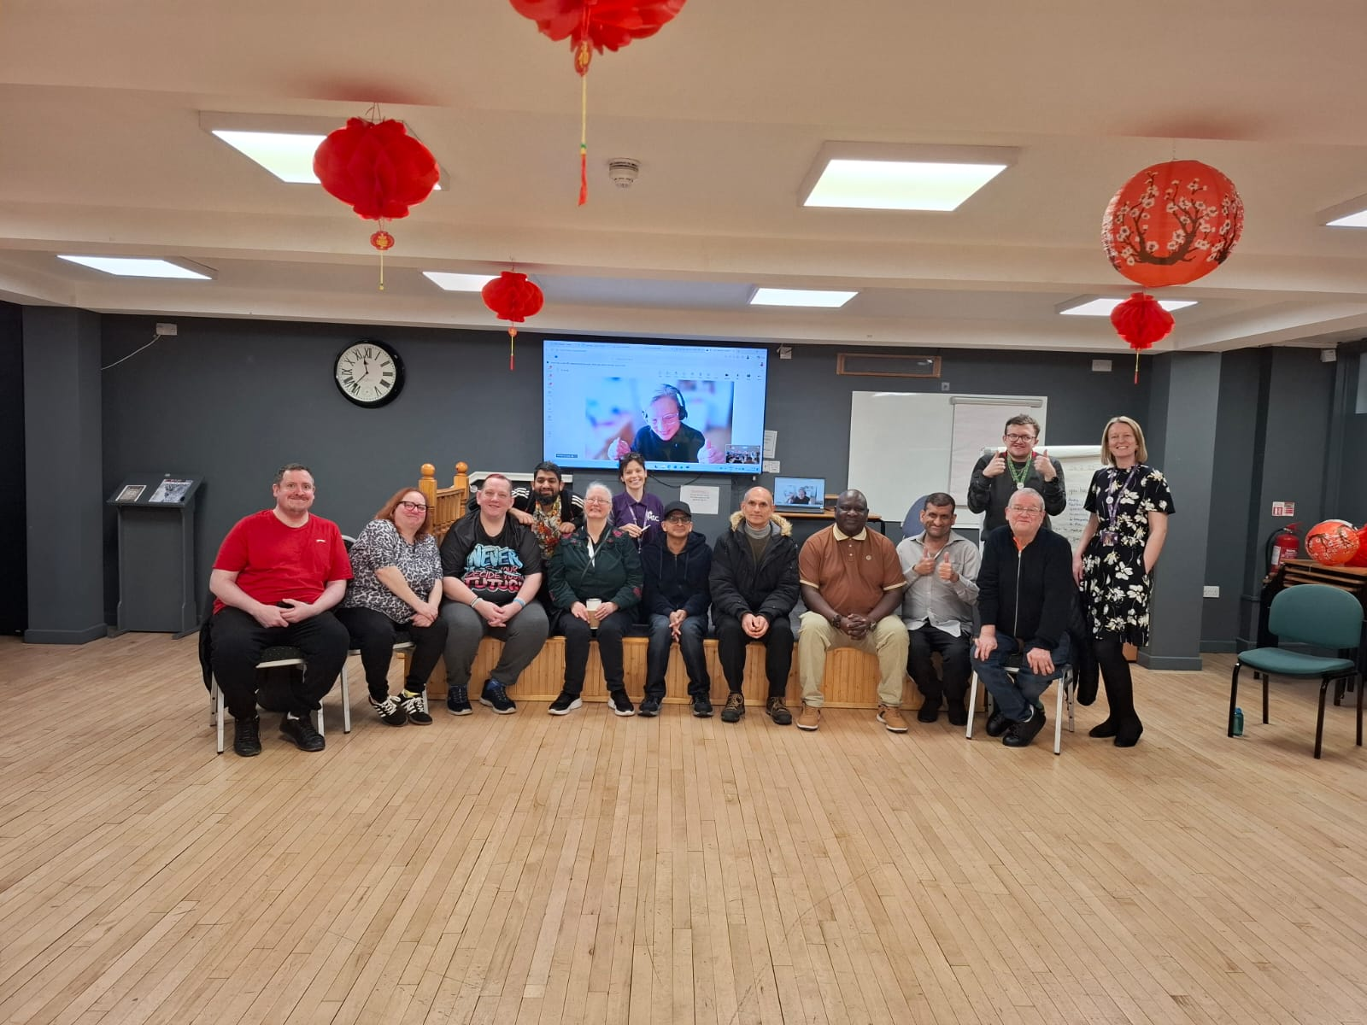
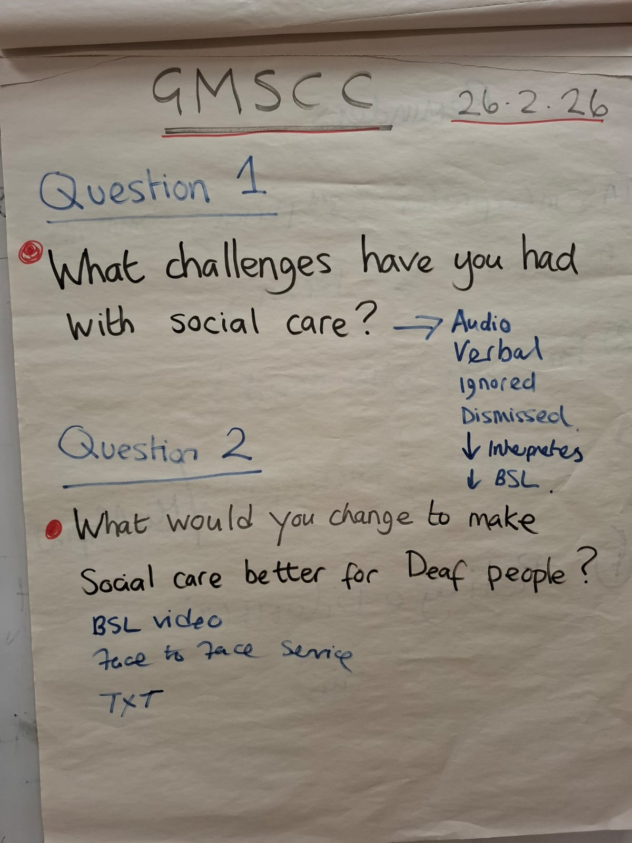

Members described experiences where accessible communication is often provided after it has been requested, rather than being built in from the start.
Key issues included:
- People have to keep asking for accessible information.
- Reasonable adjustments are recorded but not consistently made.
- Care plans and reviews are overly complex and difficult to understand.
- Easy Read is often produced too late or not at all
- Deaf people experience inconsistent access to interpreters.
- More and more information is digital only. This is not accessible to lots of people who use social care.
- There is not a clear and easy way for all services produce good quality accessible information when it’s needed.
One member asked:
“Why do we have to ask every time? It should just be there.”
Manchester People First emphasised:
“Easy Read is important from the start, not just a bolt-on at the end.”
“It is unfair to expect people to fill out massive forms and then penalise them because they ticked one wrong box in a 129-page document.”
Deaf participants highlighted risks where communication requirements are not properly understood or met and were clear that interpretation is not optional. They said that without a suitably qualified BSL interpreter there is no meaningful communication.
Members also stressed that accessible communication is not just about format. It is alaso about whether people can genuinely understand and use the information to make informed choices.
Good practice exists in parts of Greater Manchester, but this is not consistent across all ten boroughs.
The Commission agreed that accessible communication must be embedded as standard practice. It must not be treated as an optional extra.

Social Care Charging
People shared many personal experiences and reflections about social care charging and how it affects their lives.
Members described it as:
- Complicated
- Bureaucratic
- Inconsistent
- Hard to understand
- Stressful
- Feeling its unfair
One member shared:
“I have to fight for everything. I am exhausted by the fight.”
Key concerns included:
- Disability-Related Expenses (DRE) are difficult to evidence.
- Different councils count different things as DRE
- Councils repeatedly request the same evidence for lifelong conditions.
- Important wellbeing costs are often not recognised.
- There is inconsistency between boroughs on how they do their charging, creating a postcode lottery.
- People living with family can be disadvantaged.
- Information about charging is unclear and inaccessible.
- High charges can lead to debt, stress and withdrawal from care.
- There is not enough support early on to stop people from getting into debt
Members also questioned whether the administrative cost of running charging systems, including reassessments and debt recovery, represents value for money.
There was significant concern about the risk of harm, including poverty, isolation and loss of independence.
While some aspects of charging policy are determined nationally, members were clear that Greater Manchester has scope to improve fairness, consistency and transparency.

Advocacy – A Cross-Cutting Issue
Advocacy emerged repeatedly across both priority themes.
Members reported that sometimes people who are entitled to a Care Act Advocate may not get one. This can be down to the resources provided to deliver this service.
People also said that lots of people need help to access social care because it is so complicated but they are not eligible for an Advocate under Care Act.
Without advocacy, people struggle to:
- Challenge decisions.
- Understand financial assessments.
- Navigate complex systems.
- Assert their rights.
Non-Care Act and general advocacy was described as under-resourced and difficult to access.

Wider Engagement
To make sure our recommendations reflected more than just the voices in the main meetings, we reached out across Greater Manchester to listen to others.
We spoke with Disabled people, Deaf people and deaf BSL users, learning disabled self-advocates, older people, family carers, Global Majority communities, advocacy groups, care providers and people working within social care and local authorities. Some conversations were structured meetings. Others were smaller, more informal discussions where people shared openly about their experiences.

We wanted to check that the issues we had prioritised were not isolated experiences, but themes being felt across different boroughs and communities. We also wanted to learn from examples of good practice already happening.

This wider engagement gave us confidence that the recommendations are grounded in real experiences and shaped by a broad range of perspectives. A full list of organisations and networks who contributed to this work is provided in Appendix 1.
We also produced a monthly email newsletter so that anyone who was interested in our work could keep up to date with what we were doing.
We also provided an update to the Greater Manchester Disabled People’s Panel each month so that their views and input could be included.

How We Work with Decision-Makers to Make Change Happen
From the beginning, this work has been about bringing people together. It is about those with lived experience and those responsible for leading and delivering services working together.
The Commission was supported by an Oversight Group made up of senior leaders from across Greater Manchester. Their role was to support us and ensure that the work we did would get to the right places where decisions can be made to change things.
To make sure ideas can move forward, recommendations will be shared with:
- The Greater Manchester Integrated Care Partnership Board
- Individual Local Authorities
- Anyone in Greater Manchester that was interested the work
Some areas, such as social care charging, are shaped by national policy and funding decisions. However, there is still meaningful work that can be done locally by working together across Greater Manchester to improve consistency and practice.
Our aim has always been to work alongside decision-makers, not separately from them — so that lived experience directly informs the choices being made about adult social care.
We created a space where lived experience and system leadership could speak honestly about pressures, constraints and realities.
This helped build mutual understanding — not just about what needs to change, but about how change can realistically happen.
By bringing people together in this way, the recommendations reflect both lived experience and operational reality.
This is what makes this work different.

Conclusion

The Greater Manchester Social Care Commission has demonstrated that genuine co-production between lived experience and system leadership is possible and constructive. It provided a safe space to discuss issues and ideas and a way to work together on coming up with ththings that would make things better.
The Commission is ready to continue working in partnership to translate these recommendations into real change.
The work should not end in March 2026.
The momentum created provides a strong foundation for more work.

Next Steps and Future Participation
Members reflected on how the Commission could continue to grow if this work progresses into a further phase. While the Commission already brought together a broad range of voices, members highlighted the value of strengthening representation from some communities who experience social care in different ways.
In particular, there was interest in involving more people with lived experience of dementia, people living with other long-term health conditions, family carers and older people more widely. Expanding participation in this way would help ensure that future work continues to reflect the full diversity of experiences across Greater Manchester.
There were also other areas that we would like to work on such as unpaid carers and community support services.
.

Appendix – Who we engaged with:

Engagement included:
- Manchester People First
- Manchester Deaf Centre
- Manchester Sensory Services
- SignHealth
- Salford Disability Forum
- Greater Manchester Citizens
- GM Older People’s Equality Panel
- Direct Payment Action Group
- SPARC
- Disability Ambassadors
- Household Support Fund Trusted Partners
- Skills for Care
- ADASS Commissioners
- Stockport Council Inclusion Team
- Keira’s Kingdom
- Stockport Centre for Independent Living
- Alice Picard (she/her)
- Post-doctoral researcher
- French School of Public Health (EHESP)
- Aurelia project (Autonomy Regimes in Long-Term Care: Instrumentation and Territories)
- Bsl in health and social care
- SCAIN - networking group
- Manchester Disabilty Collaborative disabled people’s assembly
- Greater Manchester Disabled Persons Panel

