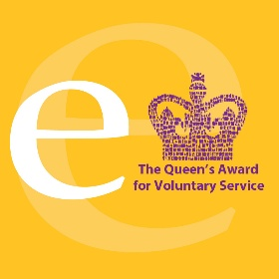

Greater Manchester Social Care Commission report

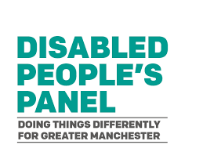
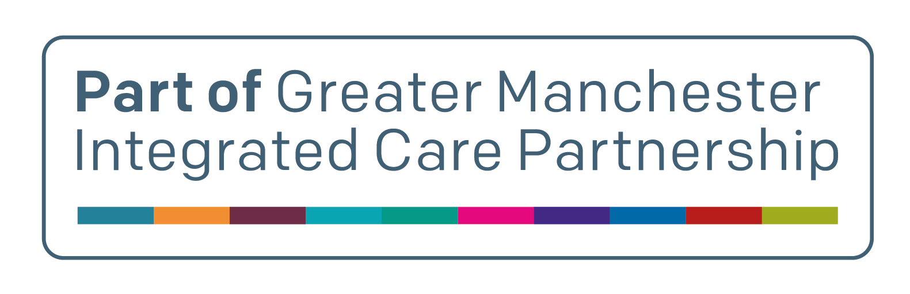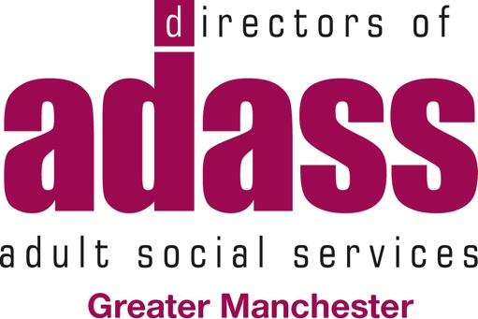





Final Report – March 2026

This is a report about the Greater Manchester Social Care Commission




This report is written in Easy Read.

Easy Read helps make information clear and simple for everyone. The Easy Read was done by Bury People First.

You may like to have someone to support you when you look at this report.

There is a British Sign Language (BSL) version of this report.

You can also get a text-only version.

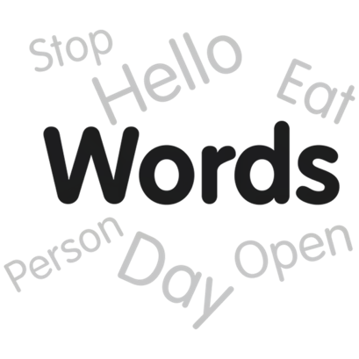
Difficult words are written in bold. There is a list of what the words mean at the end.

What is in the report

Our Recommendations for Change

What is the Social Care Commission
What we wanted to do
Who took part in the commission
What we wanted to do
Who took part in the commission
How we worked together
Conclusion
Next Steps
What the words mean

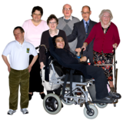
Our Recommendations for Change

The Greater Manchester Social Care Commission was set up so that people with lived experience and people in the social care system could talk about improving adult social care.



We looked at the problems that affect people every day. These were:
          - Accessible Information and Communication
          - Social Care Charging
          - Advocacy



We worked together to talk about our experiences and ideas for change. These are called recommendations.

The recommendations come first in this report.

Our Recommendations


1. Accessible Information and Communication

- The Named Social Worker Model

People who use adult social care should have a named person they can contact for help.
This means they do not have to go through the main phone lines every time they need to speak to someone.


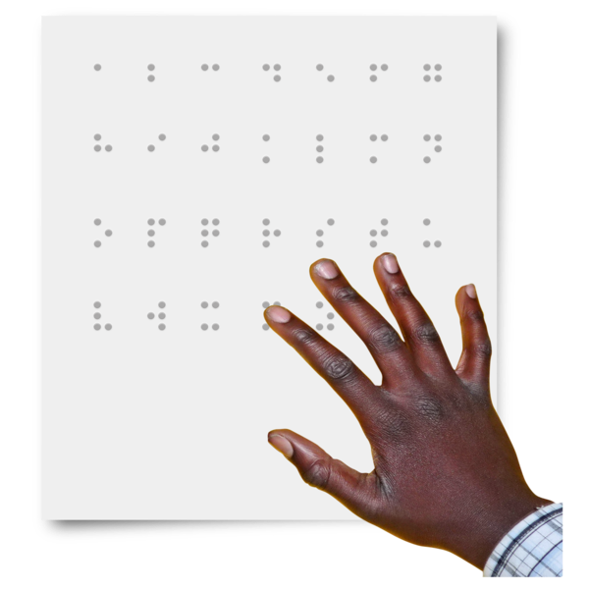

- Accessible Information

Important information about social care should be easy to read and understand. Accessible information should be available without people having to ask.

All documents should be kept in one central place, so staff and people who need support can find them easily.

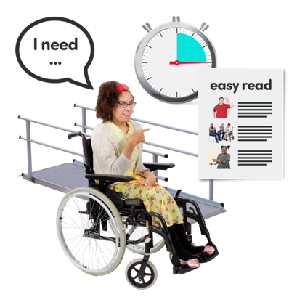
- Reasonable Adjustment Flags
Services must make sure people’s reasonable adjustments are written down and followed.

2. Care Charging

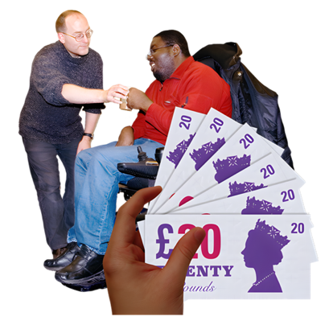

What we want to happen in the future:

We want social care charges to stop in the future

These are the things we will do to improve social care charging now.
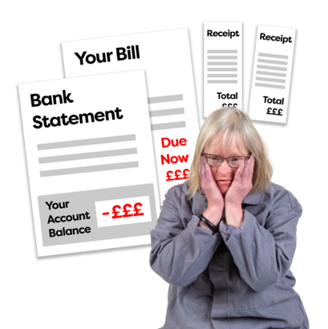

- Reduce charges and debt
Make a fairer charging system that stops people from getting into debt.



- Clear and simple charging information
Information about social care charging should be easy to understand.
People should know how much they need to pay and how that amount is worked out.

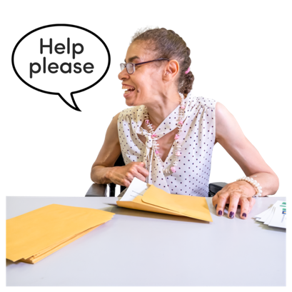
- Help people understand the charging system
People should have access to independent advice and support to help them understand the charging system.

3. Advocacy
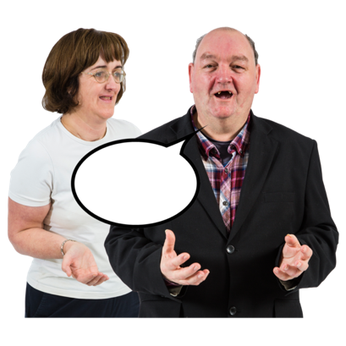
Advocacy should have enough funding so that everyone who is eligible for an Advocate can get one.

Many people need help because social care can be difficult to understand. But they are not always eligible for a Care Act Advocate.


There should be enough funding for independent advocacy for anyone who needs support to access or understand the social care system.

What is the Social Care Commission
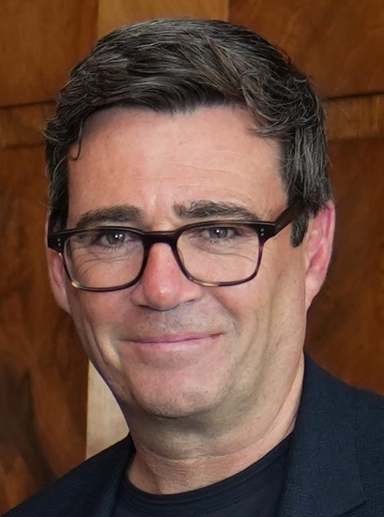
The Greater Manchester Social Care Commission was a promise from the Mayor of Greater Manchester, Andy Burnham.

It was set up to look at adult social care in Greater Manchester.

The Greater Manchester Disabled People’s Panel helped plan how the Commission could work.

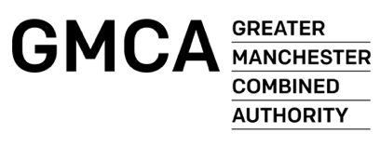
In the summer of 2025, NHS Greater Manchester and the Greater Manchester Combined Authority provided funding for the Commission.

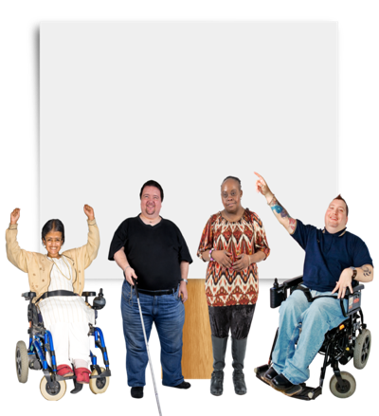

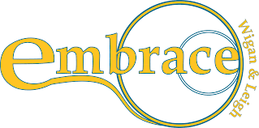
The Commission Team included people with lived experience and people from equality groups. It also included people from the social care system.

Embrace Wigan & Leigh and Disability Stockport led the commission.

The purpose was to:

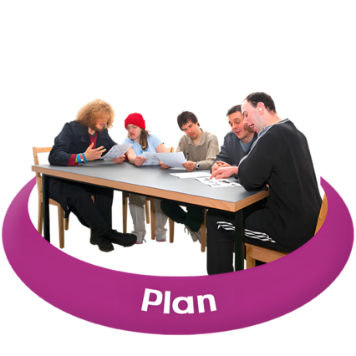
- Talk to people with lived experience.
- Find out where people face barriers or difficulties.
- Have honest discussions
- Work together on ideas that can really happen in real life
- Help change how services work across Greater Manchester so things improve for everyone

At the start of the Commission, members agreed that we must start with people’s lives, not the cost of support.

The Commission was not funded to repeat work already happening. It was funded to bring together lived experience and health and social care leaders to focus on action.

The meetings were a place where people could speak openly, listen to each other, and work together to improve adult social care across Greater Manchester.

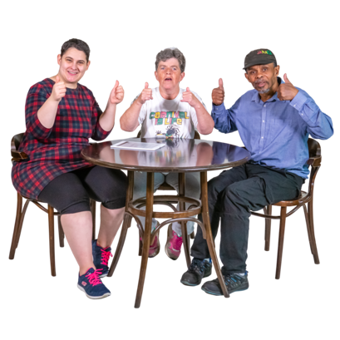
The ideal social care system

We all agreed that the ideal social care system would be :



- Care and support are free for everyone who needs it.

- Accessible information is always provided.



- Advocacy is available whenever people need it.

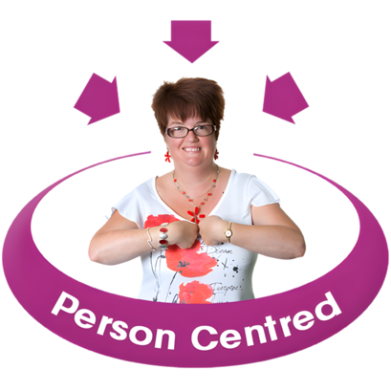
- People have real choice and control over their lives

- Lived experience is always part of decision-making.

This shows our belief that social care should support independence, dignity and equality.
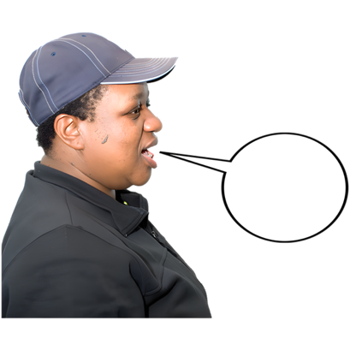
As members said in our first meeting:

“We will see real outcomes. People with lived experience will feel positive change.”

Who was part of the Commission?

The Commission brought together many different people, including:

- People who use Social Care
- Deaf and hearing-impaired people

- Learning disabled self-advocates
- Older people
- Women and Girls
- Global Majority communities
- Family carers
- Independent adult social care providers
- Greater Manchester Combined Authority
- Directors of Adult Social Care (ADASS)
- NHS Greater Manchester
- Voluntary, Community and Social Enterprise organisations
This meant that lived experience was at the centre, while still working closely with leaders in health and social care.

A member, Laurel Issen, from Salford Disability Forum, said:
“Being involved with the Commission as an expert by lived experience felt like such an empowering example of co-production… it didn’t feel like us-vs-them at all, it felt like teamwork where all of our unique perspectives were valued in coming up with solutions.”



How We Worked Together

The Commission met every month from October 2025 to March 2026.


Members agreed ground rules:

          - No jargon.
          - Speak clearly.
          - Respect access needs.
          - Co-produce as equals.
          - Be respectful of each other
          - Safe space to talk


We also had a Code of Conduct in Easy Read to help keep the work safe and inclusive.
Members not only talked about problems but worked together on real improvements.

We:


- Co-produced all Commission meetings.

- Co-production was not just something we talked about; we co-produced everything we did.

- Set up two sub-groups. They were Social Care Charging and Accessible Information & Communication.


- Held a session with Deaf participants.

- Held a session with learning disabled self-advocates.

- Held sessions with older people’s networks.

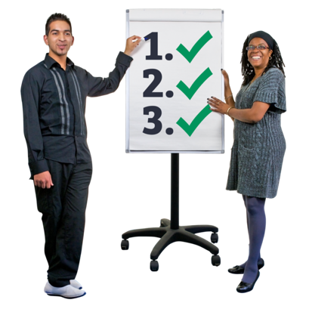
- Met with senior leaders in health and social care

- Spoke with Salford’s Fairer Charging and Welfare Rights team.
- Took part in national discussions, including the Local Government Association consultation.

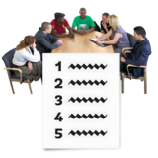

Oversight Group

- An Oversight Group helped link our work to decision-making across Greater Manchester.

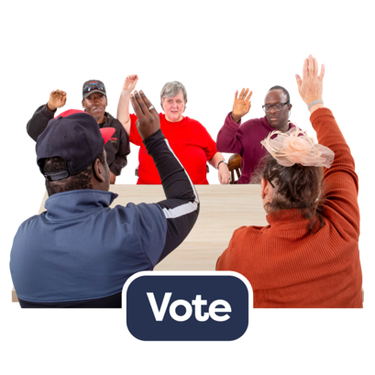
- Members voted on how we would work together

- Members voted on the priorities.

- Members agreed on what they thought the main issues were


- Members came up with ideas for solutions and discussed these ideas with people from health and social care

- Members agreed on the final recommendations

A member said:

“For many of us, this was the first time people with lived experience and system leaders had been able to sit together openly and work through issues side by side.”

What We Heard

Adult social care can be hard to understand, so we knew we could not cover everything.

We agreed to focus on 3 areas where we could make the biggest difference.

These were:

- Accessible Information and Communication,

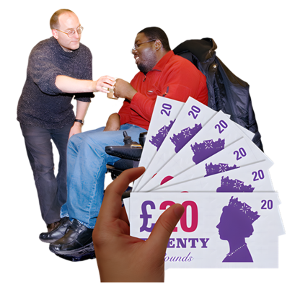
- Social Care Charging

- Advocacy.

Accessible Information and Communication
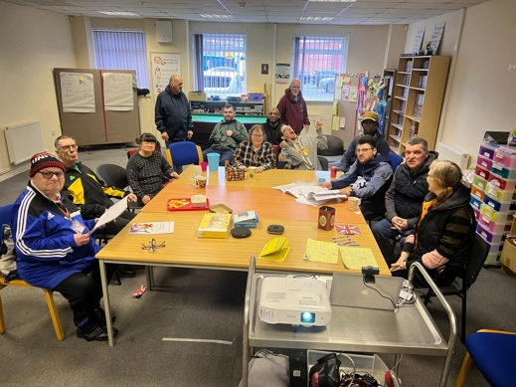

This picture is of our workshop with Learning Disabled Self-Advocates from Manchester People First.

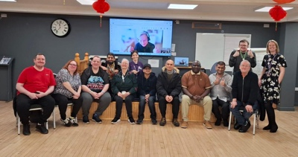
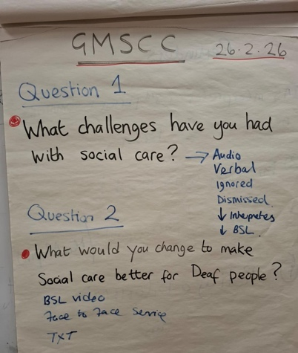
These pictures are of our workshop with Deaf people from all over Greater Manchester

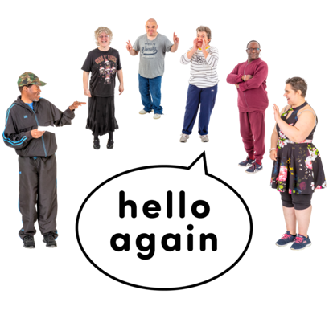
What People Told Us

- Accessible communication is often only given when people ask for it.

- It should be there from the start.

Key problems included:

- People keep asking for accessible information.

- Reasonable adjustments are not always followed.

- Easy Read information is often late or missing

- Services do not have a simple way to make good accessible information.

- Care plans and reviews are too long and confusing.

- Deaf people do not always get qualified interpreters.

- There is More information in digital only, which many people cannot access.

One member asked:
“Why do we have to ask every time? It should just be there.”

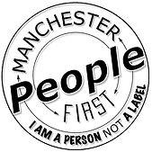
Manchester People First said:
“Easy Read is important from the start, not just a bolt-on at the end.”
“It is unfair to expect people to fill out massive forms and then penalise them because they ticked one wrong box in a 129-page document.”


Deaf participants said that without a qualified BSL interpreter, there is no real communication. Interpretation is not optional.

Members also said accessible communication is not just Easy Read for BSL. It is about whether people can understand the information and use it to make choices.

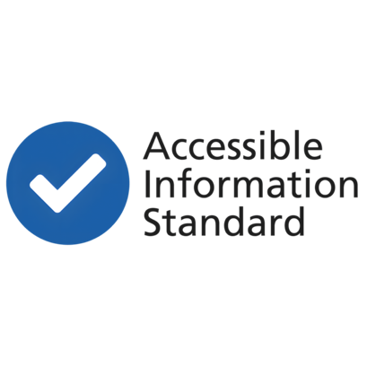
In Greater Manchester, some places do accessible information well. But it is not the same in all ten boroughs.
The Commission agreed that accessible communication must always be provided.

Social Care Charging
People shared many personal stories about social care charging. They talking about how it affected their lives.

Members said social care charging is:

- Complicated
- Full of paperwork
- Different in each area
- Hard to understand
- Stressful
- Unfair

One member said:
“I have to fight for everything. I am exhausted by the fight.”



Key worries included:

- Disability-Related Expenses are hard to prove.

- Different councils accept different things as Disability-Related Expenses.

- Councils keep asking for the same evidence, even for lifelong conditions.


- Important wellbeing costs are not recognised.

- Charging rules change between boroughs.

- People living with family can be disadvantaged.

- Information is not clear

- High charges can cause debt, stress and people stopping care.

- There is not enough early support to stop debt.

- People were very worried about the risk of poverty, isolation and loss of independence.


Members agreed that Greater Manchester can still make things fairer, even though some rules are set nationally.



Advocacy – A big issue for everyone

Advocacy came up in every discussion.
Some members said that some people who should get Care Act Advocates do not get one.

Many people need help because social care is difficult to understand. But some people are not allowed a Care Act Advocate.

General advocacy does not have enough money and is hard to get.

Without advocacy, people struggle to:
- Challenge decisions.
- Understand financial assessments.
- Get help to understand services
- Know their rights and speak up for what they should get.

Who else was involved in the commission
We spoke to many people across Greater Manchester, including:

- Disabled people
- Deaf people and BSL users
- People with learning disabilities
- Older people
- Family carers
- Global Majority communities
- Advocacy groups
- Care providers
- People working in social care and local authority
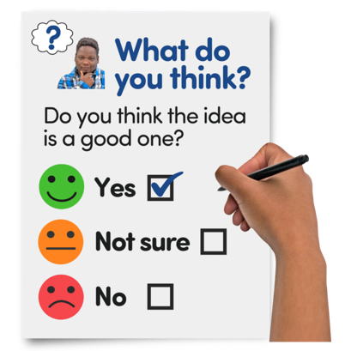
We wanted to check if people in different areas of Greater Manchester had the same issues.
We also wanted to learn from good work already happening.
You can see a full list of groups we spoke to at the end of the report in Appendix 1



We sent a monthly email newsletter and gave monthly updates to the Greater Manchester Disabled People’s Panel about what we were doing.

How we work with the people who make decisions to make change happen

This work is about bringing people together. This means people with lived experience and people who run services.

Oversight Group

The Commission has an Oversight Group. This group was made up of senior leaders from across Greater Manchester.

Their job was to support our work and help make sure it reached the people who can make change happen.
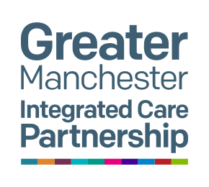
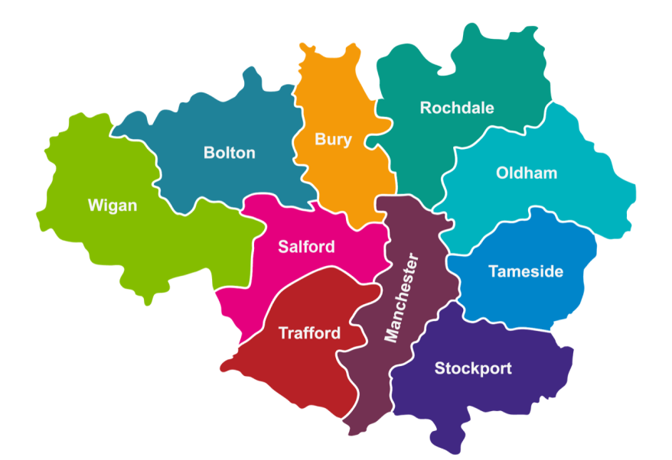
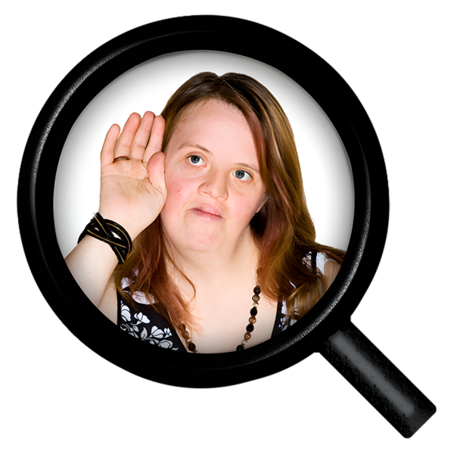
Our recommendations will be shared with:

- The Greater Manchester Integrated Care Partnership Board

- Local Authorities

- National policy

- Anyone in Greater Manchester interested in the work


Some things, like social care charging, are decided by the government.

Policy

But Greater Manchester can still work together to make things fairer.

We want to work with decision-makers so that people with lived experience can help change adult social care.

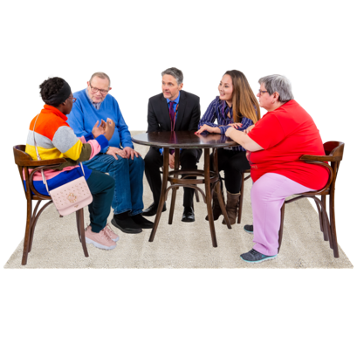
We made a safe space where people with lived experience and leaders could talk honestly about problems.

This helped everyone understand each other better and see what needs to change and how change can happen.

This is what makes the Commission’s work different.

Conclusion


The Greater Manchester Social Care Commission has shown that true co-production is possible.

This means people with lived experience and leaders who run services work together as equals

It gives people a safe space to share problems and ideas, and to work together on solutions.

The Commission is ready to keep going to turn these recommendations into real change.

The work should not stop in March 2026. We want to carry on and build on what we have started.


Next Steps

Members talked about how the Commission could work in the future.

Members said it would help to involve more people:

- People with lived experience of dementia
- People with other long term health conditions
- Family carers
- Unpaid carers
- Community support services

This will help make sure future work includes the different experiences of people across Greater Manchester.

.

Appendix – Who we spoke to:

People that we spoke to included:
- Manchester People First
- Manchester Deaf Centre
- Manchester Sensory Services
- SignHealth
- Salford Disability Forum
- Greater Manchester Citizens
- GM Older People’s Equality Panel
- Direct Payment Action Group
- SPARC
- Disability Ambassadors
- Household Support Fund Trusted Partners
- Skills for Care
- ADASS Commissioners
- Stockport Council Inclusion Team
- Keira’s Kingdom
- Stockport Centre for Independent Living
- Alice Picard (she/her)
- Post-doctoral researcher
- French School of Public Health (EHESP)
- Aurelia project (Autonomy Regimes in Long-Term Care: Instrumentation and Territories)
- British Sign Language in health and social care
- SCAIN - networking group
- Manchester Disability Collaborative disabled people’s assembly
- Greater Manchester Disabled Persons Panel

What the words mean

Eligible – are the rules that decide if you can have care and support from adult social services.

Equality Groups – a group of people who work on discrimination, which means making sure everyone has the same opportunities and is included

Barriers – things that stop people from being involved in everyday life

Coproduction and Co-produce - where people with lived experience and people who work in health and social care work together to improve services.

Disability related expenses- the extra costs you pay because of a disability or medical condition.

This Easy Read report was produced by self-advocates from Bury People First.

