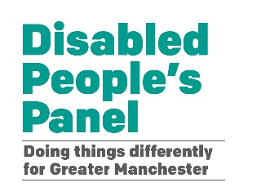

The Greater Manchester Disabled People’s Panel

Mental Wellbeing Funding for Disabled People

Groups can ask for up to £5,000 to support projects that help the mental wellbeing of disabled people.
£5,000

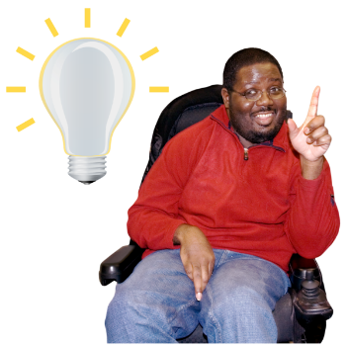
What we want to do

We are looking for good ideas that could make things better for disabled people.

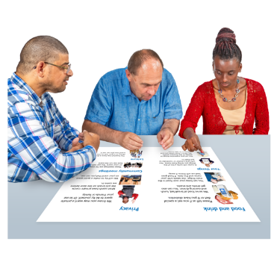
We want the project to be led by disabled people.

Or

Co-produced with disabled people using the Social Model of Disability.

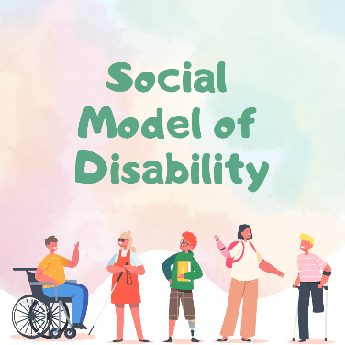
You can find out more about the social model of disability here:

https://breakthrough-uk.co.uk/social-model-of-disability/

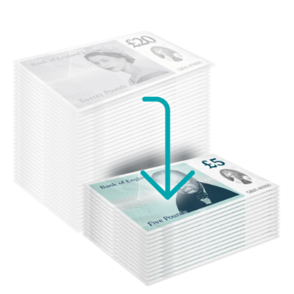
£100,000

We want to fund groups with money less than one hundred thousand pounds.

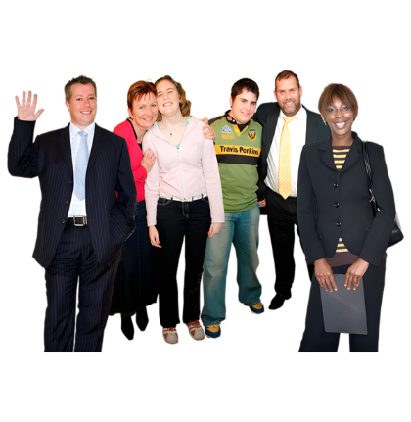

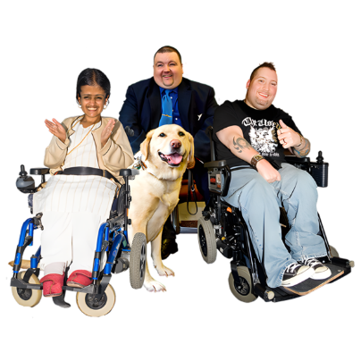
We want to fund projects that think about the needs of disabled people, including their gender, sex, sexuality, age, faith and culture.

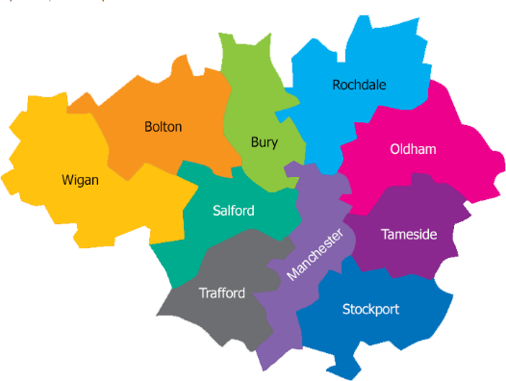
The group must be based in Greater Manchester.


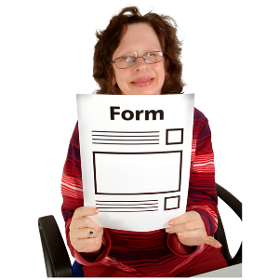
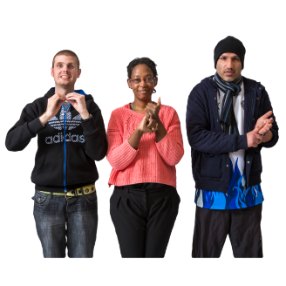
How you can apply

You can apply for the money using video, audio, text, and British Sign Language.

About the funding

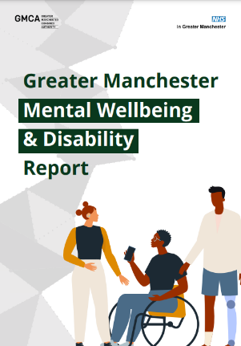
The money is from Greater Manchester NHS after we co-produced a report with them. If you want to apply for the money, please read the easy read report about Greater Manchester Mental Wellbeing and Disability here: https://gmdisabledpeoplespanel.com/gm-mental-wellbeing-and-disability-report/
If you want to apply for the funding

Think about and answer these 3 questions:
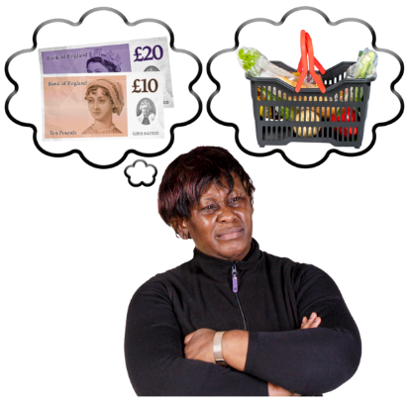

- How much money do you want?

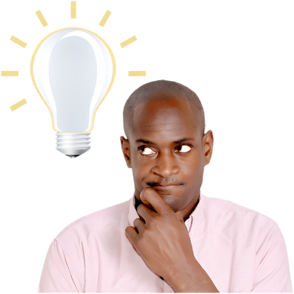

- What will you do with the money?

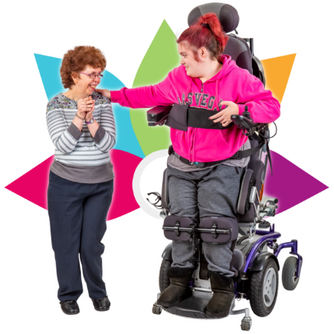

- How will this support the mental wellbeing of disabled people?

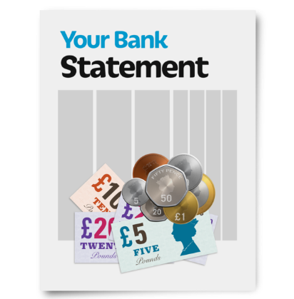
You will need a group bank account or the help of a group that can manage your money.

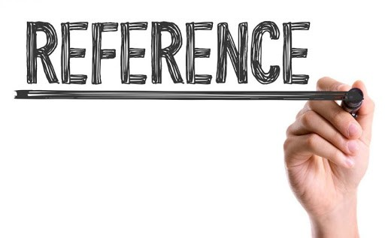

You will need 2 references.

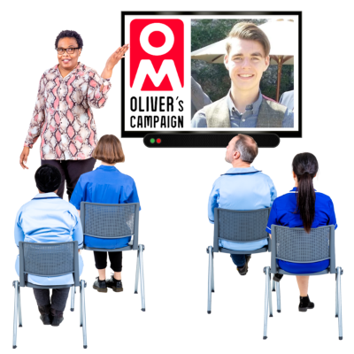
Our Project

You will be asked to go to a meeting to show what you are doing.

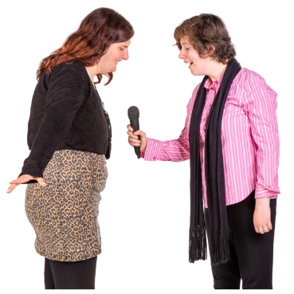
You will be asked to tell us the story about your project so we can share it with others. This is called ‘Community Reporting’

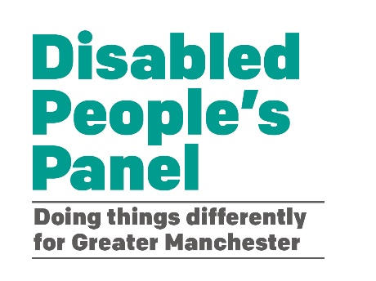

For more information contact

