
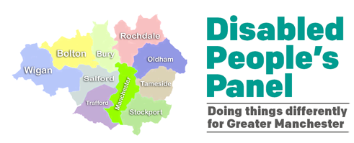
Greater Manchester Disabled People’s Panel
Year 5 Annual Report 2023 - 2024


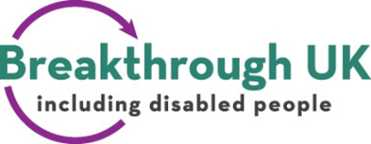
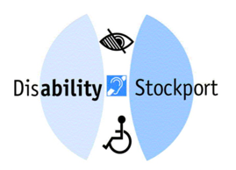



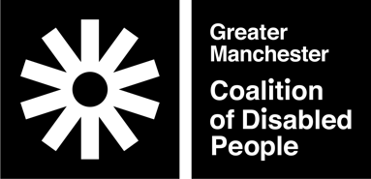


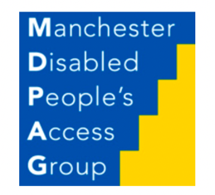
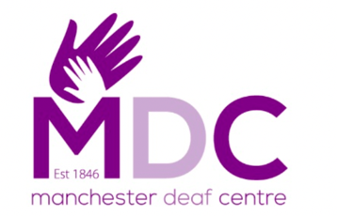


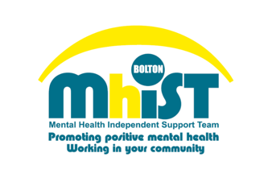
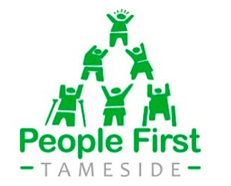
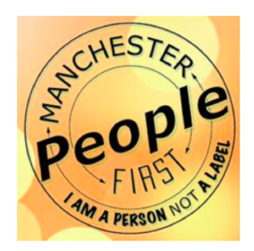
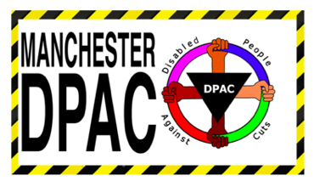

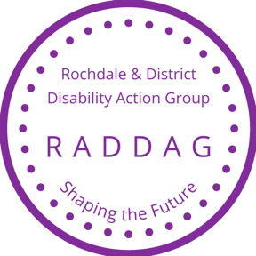

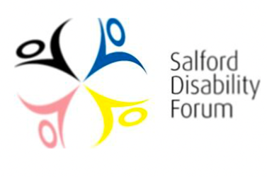

‘Nothing About Us Without Us’
- Disabled People everywhere demanding their rights and inclusion in society.
Contents
Greater Manchester Disabled People’s Panel 0
Year 5 Annual Report 2023 - 2024 0
Executive Summary 2
Co-chairs’ foreword 5
Introduction to the Panel and our priorities 8
Activities and highlights 12
Plans for 2024/25 18
Thanks and further information 20

Executive Summary
At the February Panel meeting, the Mayor, Andy Burnham, outlined his vision for devolving control of benefits from Westminster to Greater Manchester to better support disabled residents through personalized, community-based assistance. Panel members agreed to work with the Mayor on any future proposals. The Panel co-chair attended the Greater Manchester Combined Authority meeting in November to address the Greater Manchester response to the Disabled People's Panel Big Disability Survey. You can watch the GMCA meeting here (starts around 26min30sec). The Panel helped the huge victory for collective working in stopping the closure of railway station ticket offices. The Panel held the national Disabled People's Organisation conference at the People's History Museum with Andy Burnham giving keynote address. GMDPP welcomed the extension of the textline by 10 councils / GMCA for deaf and hearing impairment and to be included in number in all GMCA letters.
The Panel continued to enjoy a high media and political profile receiving requests from local councillors, MPs, the EHRC and Government Departments (DWP, Ministry of Justice and Minister for Disabled people) for information on the impact of policy on disabled people, for example the impact of the Household Support Fund, social care charging, pre-payment metres, adequacy of welfare benefits, Work Capability Assessments (the Mayor wrote to the Government to communicate our concerns), benefit fraud investigations and administration. We have submitted out findings to select committees such as poverty, housing and benefits select committees. We have also submitted our findings to the UN Convention on Economic, Social and Cultural Rights and the UN Convention on the Rights of Disabled People. Our work has been mentioned in the Mirror, Disability News Service, Manchester Evening News, the Guardian, BBC National news, ITV Granada & national news. Our project with the British Gas Energy Trust has led to a greater understanding across the GM system about the lack of accessible advice for disabled people and may lead to additional future funding. The project also provided added-value benefits of strengthening closer working between Panel members in terms of management of GM DPO’s and support of disabled advice workers. It also led to a successful bid for extra advice funding for advice for disabled people with Greater Manchester Law Centre.

Co-chairs’ foreword
I am pleased and proud to present this report, highlighting the remarkable work the Greater Manchester Disabled People’s Panel has been able to achieve during the past year.
During the past year the Panel has gone from strength to strength. The amount of work we are doing seems to have increased. For an organisation that meets eleven times per year our output is prodigious. Of course, our main output is our contribution to Greater Manchester Disabled Peoples strategy, there are multiple challenges facing disabled people and multiple priorities that are all important but as Panel time is limited, the Panel have chosen to focus on a three key priorities.
I am well aware that in the past people have looked to the Greater Manchester Big Disability Survey as ‘the output’, but really the work is far deeper than that. The surveys done at height of Covid in 2020 and as the Cost of Living Crisis hit in 2022 helps to highlight where the problems are and gives us a steer regarding what to work on.
Over the past year I think that the main achievements, of which much more later, of the Panel have been:
- All of the ten GM councils have agreed to nominate a disability ally with whom our panel members can communicate regarding all things disability related. All ten of them have done and things are moving on well.
- The Disabled People's Organisation conference at the People's History Museum where the Mayor Andy Burnham gave a keynote address.
- And it would be remiss of me not to mention the huge victory of the Panel in its collective work with key partners to stop the closure of railway station ticket offices.
I know that our work plan for the ensuing year 2024 / 25 is at least as challenging as it has been for this year.
As the work of the panel is co-produced aspects of it have become increasingly apparent. Panel members feel empowered to take control, they feel that they belong, and they are coming up with ideas about how they want to make their own differences. I know that our disabled peoples Panel is starting to help to build stronger, more connected communities as we intended. After all, collectively the Panel represents over 24,000 disabled people in the GM city region and are regularly in contact with a further 24,000 other local people via our communication networks.
In closing I would like to thank the other co-chairs and members of the Panel for their ongoing and diligent support.
Melvin Bradley – Greater Manchester Disabled People’s Panel Co-chair

Introduction to the Panel and our priorities
The Panel is convened by the Greater Manchester Coalition of Disabled People (GMCDP) in partnership with GM Mayor Andy Burnham and the GM Combined Authority (GMCA). There are 17 Disabled People’s Organisations (majority or wholly led and run by disabled people as distinct from charities) on the Panel drawn from across the city region, they are:
Beyond Empower • Breakthrough UK • Bury People First • Disability Stockport • Embrace Wigan & Leigh • GM Autism Consortium Advisory Committee • GMCDP (Convenor) • George House Trust • Manchester Deaf Centre • Manchester Disabled People’s Access Group • Manchester Disabled People Against Cuts • Mental Health Independent Support Team • Manchester People First • People First Tameside • Rochdale And District Disability Action Group • Salford Disability Forum • Stand Up Sisters
In 2023-2024 we had three Co-Chairs: Sara Crookdake (Disability Stockport), Chris Hamnett (Embrace Wigan & Leigh), Melvin Bradley (Mental Health Independent Support Team). The Panel Steering Group meets weekly and comprises: the three Co-chairs, GMCDP manager, two Panel Officers, and officers from GMCA.
We pay each member organisation £800 per year to help cover their costs for the extra work they do plus we cover any access needs members have and providing information in accessible formats. The Co-chairs receive an additional £500 annually as a reflection of the extra work they do. This is how we operate ethically in line with the disabled people’s movement principles and valuing disabled people’s lived expertise and labour.
We also have a wider associate network of interested stakeholders, who do not attend meetings, with whom we share information.
The Panel and members operate from the perspective of the Social Model of Disability. This is the model developed by disabled people since the 1970’s and holds that while we individually have impairments or conditions, it is the barriers in society, be they physical, ideological, social, that collectively disabled us and exclude us form society.
The Panel meetings in 2023/24 were prioritised according to the issues identified in the Greater Manchester Big Disability Survey 2022. For 2023/2024 we prioritised Money, Benefits, and Energy Costs, Housing and Physical Access. In the Survey the Panel identified five immediate actions and structural recommendations which we used as progress measurement indicators. The UK has been assessed by the United Nations to be enacting ‘Grave & Systemic’ violations of disabled people’s rights, many related to standard of living and sufficiency of income and support. The Panel seeks to alleviate and redirect policy from this 15 years of austerity towards an inclusive future where rights are realised and independent living is fully supported.

Activities and highlights
Activities
The Disabled People's Panel have held monthly meetings and easy meetings, focussing on: welfare benefits, accessible information, built environment and night time economy, changes to voting requirements, GM Good Landlord’s Charter and housing, transport, work planning for 24/25 and the Greater Manchester response to the Panel’s Big Disability Survey. The latter highlighted issues with housing, transport, social care charging, a lack of choice and control, and difficulties accessing healthcare and improving involvement of disabled people.
The Panel continued to work with policy leads to highlight problems relating to debt, access to advice, benefits, social care and transport (including new buses, Bee network journey planning, on-demand transport and concessionary passes). The Panel completed its research project on advice services for disabled people and presented this to British Gas Energy Trust, who funded the project. The Panel also worked with GMCA to review the information contained on the GM Elects website to assess how it met the needs of disabled people.
On behalf of the Panel MDPAG created guidance on lobbying Local Authorities on M4 (3) wheelchair accessible standard for 10% of new builds in Local Plans. GMCDP's Housing Working Group spoke at Housing 2023 Conference and included quotes from the Panel’s survey to highlight issues in Greater Manchester. We undertook work with GM planning leads to ask the ten authorities a series of questions about how planning authorities currently engage with Disabled People and DPO's.
The Panel shared opportunities for disabled people to be involved in local and national consultations and met regularly with the Equality and Human Rights Commission.
Panel representatives attended:
- the GM Cost of Living Response Group – we continued to shape the GM Residents Survey to capture the lived-experience of disabled people living in poverty
- Mayor's Energy Providers working Group - We reported that disabled people are experiencing increasing energy poverty and raised concerns about disabled energy consumers receiving communications from energy retail suppliers referencing warrants to force-fit, after the voluntary agreement to cease warrant-seeking. We helped to draft the priority services register letter which was sent out by the GM Health and Social Care Partnership to disabled people using medical devices
- Digital Inclusion Action Network – we co-produced a new digital support resource for disabled residents
The Panel also attended the GM Hate Crime Partnership, and DPO Forum England. Panel co-chairs met weekly and attended Panel Chairs meeting as well as the Tackling Inequalities Board. Panel officers also met weekly and attended GMCA Panel facilitators meetings. This means disabled people are now more thought about and engaged with at the highest levels of policy creation and brings us closer to a UNCRDP complaint way of working in GM.
Panel representatives also continued to meet the Government’s Disability Unit and the Minister for Disabled People. Our co-chair participated in the selection process of the new Group Chief Executive (GMCA & TfGM). The work of the Disabled People's Panel continued to focus on the impact of poverty and the cost-of-living crisis on disabled people.
The Panel attended the meeting of the Greater Manchester Association of Directors of Adult Social Services to highlight barriers to independent living.
The Panel also contributed to local and national policy on care charging and institutional abuse (working with the international disability arm of Human Rights Watch) and the UK Covid Inquiry. Work from previous years also highlighted lasting impacts for example in the allocation of Mental Health and Well-being Grants to improve access to talking therapies for disabled people and to the use of our Big Survey by DPO’s in other areas of the country, for example Disability Cornwall. The Panel attended both GM Networks Connect events combining Social and Climate Justice. We also identified a need for disability specialist Independent Domestic Violence Advisors in GM.
And finally one of our co-chairs, Sara Crookdake received an MBE.

Plans for 2024/25
The Panel have developed a new workplan for 2024/25. The priorities have been agreed following discussions between members of the Greater Manchester Disabled People’s Panel and are intended to dovetail with the priorities of partners, especially the Greater Manchester Combined Authority (GMCA). It should be noted that the number of urgent priorities facing disabled people outstrips the capacity of the Panel. Our Thematic Priorities for 2024 to 2025 are:

- Disabled people and Work: Focussing on the barriers in the labour market, not victimising individuals in the benefits system.
- Poverty: we are over-represented in poverty and inequality is growing, we will challenge ongoing austerity to change this.
- Social Care: we seek free at the point of need a system that supports independent living in line with the UNCRDP.
- Strengthening the Panel: Refreshing membership and cementing procedures to maximise impact.

The Panel has learned from the Covid-19 Pandemic and the cost-of-living crisis that we need to be flexible in our approach as new opportunities and challenges arise. A new Government will bring new opportunities and challenges. To remain alert and agile to changes we will review our workplan regularly.

We have also identified a list of potential priority project areas that we would work on, should sufficient funding, resource and capacity exist in to undertake them effectively, these include Devolution of Benefits (to make recommendations on a potential GM devolved benefits model), Access to Health Care, Education, Housing and the Built Environment, Elections and Political Participation, engagement with Great British Railways, Domestic Abuse and disabled people, and a “Know Your Rights” event.

Thanks and further information
We would like to offer a special thank you to our outgoing co-chair Sara Crookdake of Disability Stockport, who has been a strategic voice for disabled people in Greater Manchester. We are grateful for the continuing support from the Mayor, his office, GMCA and its officers. Special thanks to Mahmuda, Elaine, Adrian, Rachel, Halima, Ellen and Anne at the GMCA.
GM Disabled People’s Panel
gmdisabledpeoplespanel.com
Email: Panel@gmcdp.com
Officers
Jane Bevan, Strategic Lead
Email: Jane@gmcdp.com Call/Text: 07940 797 363
Rick Burgess, Outreach and Development Lead
Email: Rick@gmcdp.com Call/Text: 07367 754 595
Host/Convenor GM Coalition of Disabled People

