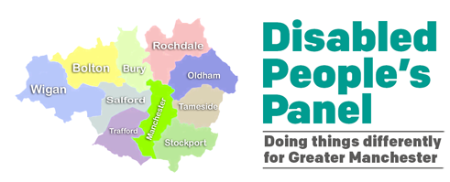

Greater Manchester Disabled People’s Panel
Year 3 Annual Report 2021 - 2022

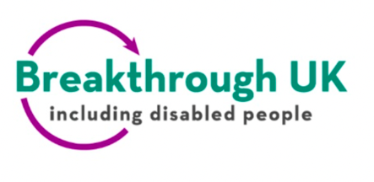
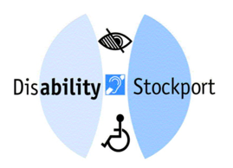


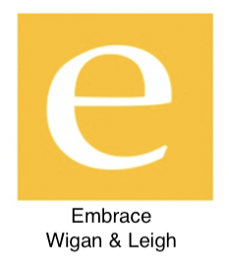
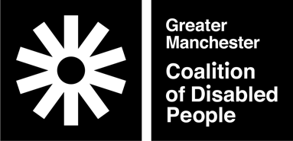
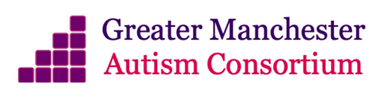

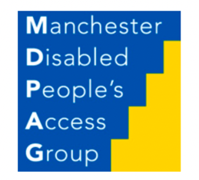
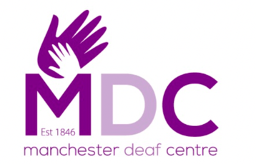
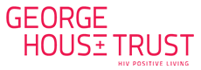

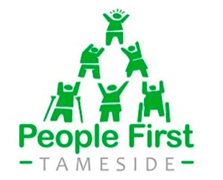
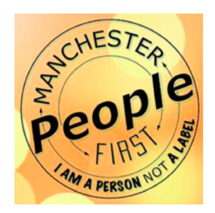
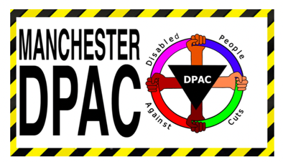

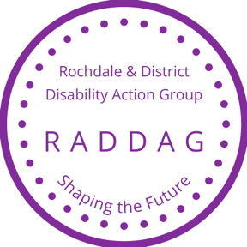
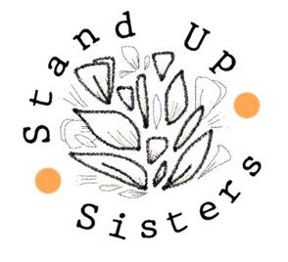
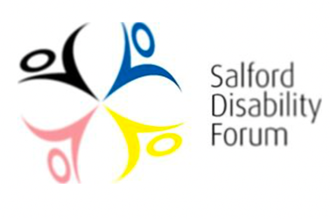

‘Nothing About Us Without Us’
- Disabled People everywhere demanding their rights and inclusion in society.

Contents

Page 3 About the Panel
Page 5 Annual Report
Page 9 Conclusion

1. About the Panel

The Panel is convened by the Greater Manchester Coalition of Disabled People (GMCDP) in partnership with GM Mayor Andy Burnham and the GM Combined Authority (GMCA). There are 15 Disabled People’s Organisations (majority or wholly led and run by disabled people as distinct from charities) on the Panel drawn from across the city region, they are:
Breakthrough UK • Bury People First • Disability Stockport • Embrace Wigan & Leigh • GM Autism Consortium Advisory Committee • GMCDP (Convenor) • George House Trust • Manchester Deaf Centre • Manchester Disabled People’s Access Group • Manchester Disabled People Against Cuts • Manchester People First • People First Tameside • Rochdale And District Disability Action Group • Salford Disability Forum • Stand Up Sisters
We have three Co-Chairs: Michele Scattergood (Breakthrough UK), Chris Hamnett (Embrace Wigan & Leigh), Sarah Cross (Rochdale And District Disability Action Group).
The Panel Steering Group meets weekly and comprises: the three Co-chairs, GMCDP manager Nicola McDonagh, Panel Officers Jane Bevan and Rick Burgess, and Anne Lythgoe joins us from GMCA.
We pay each member organisation £800 per year to help cover their costs for the extra work they do plus we cover any access needs members have and providing information in accessible formats. The Co-chairs receive an additional £500 annually as a reflection of the extra work they do. This is how we operate ethically in line with the disabled people’s movement principles and valuing disabled people’s lived expertise and labour.
We also have a wider associate network of interested stakeholders who don’t attend meetings with whom we share information with.
The Panel and members operate from the perspective of the Social Model of Disability.

Contact Details
GM Disabled People’s Panel
gmdisabledpeoplespanel.com
Email: Panel@gmcdp.com
Officers
Jane Bevan, Strategic Lead
Email: Jane@gmcdp.com Call/Text: 07940 797 363
Rick Burgess, Outreach and Development Lead
Email: Rick@gmcdp.com Call/Text: 07367 754 595
Host/Convenor GM Coalition of Disabled People
GMCDP.com
GMCDP, Unit 4
Windrush Millennium Centre
70 Alexandra Road, Manchester, M16 7WD
Email: info@gmcdp.com Call/Text: 07782 540 531

2. Annual Report Year 3 2021 - 2022

‘We are leading the way - I don't think the other Mayoral combined authorities have all done what we've done. And that's down to the work that you've done’
- Mayor of Greater Manchester Andy Burnham
As the Panel began its third year the Country entered the second year of the Covid Pandemic. The Panel continued to meet with greater than normal frequency in order to gather intelligence from our member organisations to feed into the system response and to disseminate information outwards. This included attending the GM Humanitarian Aid group and specific consultation with vaccination programs. Weekly online meetings of the steering group to facilitate effective longer monthly meetings for the whole Panel looked at specific themes and brought in external speakers to help our discussions and deliberations.
With our partners in the Greater Manchester Combined Authority, we expanded our contact and work across the City Region including some specific task groups on mental health wellbeing, for which we secured additional funding, concessionary travel pass reform, accessible transport, digital inclusion, and vaccination. We also continued to progress the issues and recommendations from our 2020 survey and encourage development of disabled people’s representation and organisation in areas with less infrastructure including Trafford and Oldham.
For the United Nations International Day of Disabled people on 3rd December we organised a meeting of disability and equality representatives to forge better network links between us and their local DPO’s and the CA equality portfolio.
In February we organised a follow up from our hustings, we held a public event where the Mayor answered questions from disabled people across GM and discussed policy moving forward. We intend to continue to hold these a couple of times a year as everyone’s feedback was very positive.
We progressed a workstream on the Bee Network – advising them on engagement with the disabled community, expanding on our existing work on inclusive active travel and discussions with TfGM.
We discussed with the CA making the UN Convention on the rights of Disabled People a standard for the City Region and prepared a briefing on a regional rights enforcement structure. This is perhaps becoming more pressing as effort to abrogate Human Rights are emerging at the Westminster level.
We were asked to compile our top ten of inaccessible train stations we would like to be made accessible as a priority, the list is: Reddish North, Levenshulme, Bredbury, Oxford Road, Salford Central Station, Bryn, Irlam, Stockport, Greenfield, Davenport. We also calculated, from their own estimates, that Network Rail’s existing timeframe to make all GM stations accessible would take until the 2080’s, which we told them was not good enough. We worked with the Mayor to have a video filmed with activist Nathaniel Yates about inaccessible stations and facilitated another video report with the Manchester Evening News about this issue.
We supported the Stop Care Charging Campaign and now have detailed FOI responses in GM about charges and debts disabled people are incurring.
We supported the Workforce Disability Collaborative Project which has now received funding. We looked at the advantages of flexible working and engaged with the TUC’s equality and strategy officer who presented to the full Panel. Reasonable adjustments, access to work and flexible working all increase employment of disabled people and we continue to support this.
As part of our Digital Inclusion work in the first lockdown we teamed up with People First Manchester and Prof. Erinma Bell’s Carisma organisation to distribute free tablets, with Wi-Fi connection, data and accessible peripherals to 10 recipients in learning disabled and communities experiencing racism, funded by the Good Things Foundation, helping families and organisations get online. This also provide valuable learning of what works and what is need that we fed into both the Humanitarian Aid group and Digital Inclusion Action Network.
We held a disabled people’s hustings for the Mayoral elections and joined Pride organisers across GM to make Pride events more accessible, ran a focus group on Gender Based Abuse to better inform GM strategy.
We facilitated discussions for the new Design for the Mind guidelines being produced for architects and continued a strand of work on inclusive active travel. Later in the year we invited Independent SAGE (Scientific Advisory Group of Experts) to a Panel meeting to discuss the particular challenges disabled people faced during Covid. While we learned from them, they also learned from us and the need to do more focussed work on the challenges disabled people were facing. Our wider influence led to a Cheshire Disabled People’s Panel forming and advice for to Disabled People’s Organisations (DPO’s) in Bristol.
Mayor Andy Burnham’s continuing support was much appreciated and ensured important engagement with National Government which in turn has led to the formation of a National DPO Forum for England. We ran workshops on democratic engagement and representation of disabled people with leading academics Dr Elizabeth Evans and Dr Stefanie Reher who authored government report and their own independent evaluation on Disabled People’s inclusion in elected office. We worked on making elections inclusive and this was accepted and implemented across the region.
The Panel was recognised at a national level as good practice by the King’s Fund, the parliamentary committee on rights and the EHRC, and by Reclaiming Our Futures Alliance, a national umbrella organisation of DPO’s.
The Panel is the result of pioneering work by the Mayor, Combined Authority and disabled people’s organisations and it is this structure that has enabled us to do this work and help others to realise their ambitions. We are still developing and evolving, but we believe this is absolutely the right approach to how authorities and disabled people and their organisations can work together to improve society for us and everyone. We continue to enjoy the value and impact of this work. We continue to be excited by the possibilities ahead. In Manchester we really do things differently!

3. Conclusion

Year 3 2021 - 2022 was as full and packed as ever, we expanded our networks and influence while coping with the pandemic. We added new member organisations to improve our intersectional representation (George House Trust, Stand Up Sisters, Bury People First).

We are grateful for the continuing support from the Mayor, his office, GMCA and its officers and really feel that disabled people are gaining a voice and prominence within Greater Manchester that reflects a growing openness to a more inclusive, diverse and equal society.

We recognise there is still faltering representation in Trafford and Oldham, and we will continue to seek opportunities to develop organisation in those communities. It is clear that areas that have a Disabled People’s Organisation in it, always results in better lives for disabled people there. Ideally we would like to see sustainable, funded democratic DPO’s in every district, being active members of the Panel, so collectively we can strategically influence how our City Region develops.

There is still so much more to do, but we feel the Panel is ideally suited to meeting the challenge. We want to continue to engage more deeply with our community and bring that direct lived experience directly to bear on the very highest decision making and policy processes, to continue to revitalise democratic processes to improve the City Region we are proud to call home.

